Database Basics MS SQL Exam – 8 April 2021
Exam problems for the “Database Basics MSSQL Server” course @ SoftUni" Submit your solutions in the SoftUni judge system at Software University.

Service
The city mayor, came up with the idea to create an online platform where all the citizens can report about different problems and a special organization will work to resolve all the incoming reports. This organization has a few departments each of which is responsible for a set of problem's categories in which users can submit a report. In each department there are employees who get assigned to a report. Of course, this huge platform needs a reliable database to store and process the information and the mayor has asked for the best specialist in this area. That’s why you got chosen! Congratulations and good luck!

Section 1. DDL (30 pts)
You have been given the E/R Diagram of the Report Service:
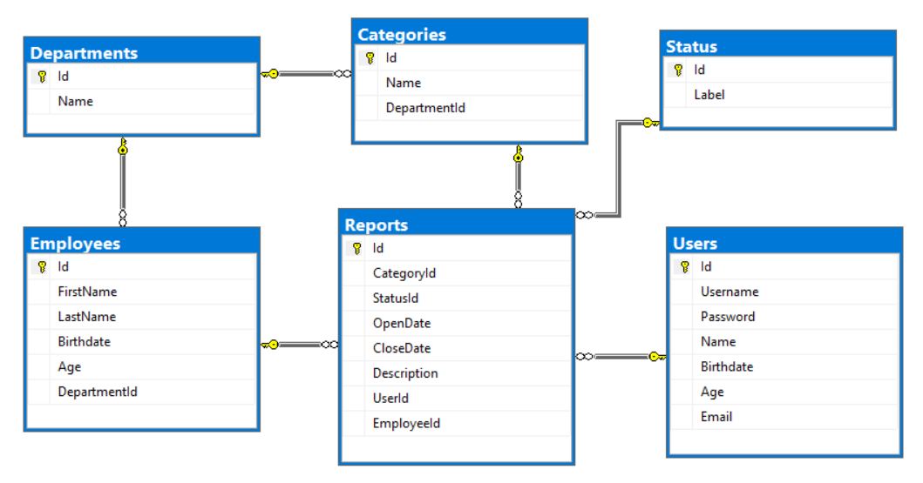

Create a database called Service. You need to create 6 tables:
- Users - contains information about the people who submist reports
- Reports - contains information about the problems
- Employees - contains information about the employees
- Departments - contains information about the departments
- Categories - contains information about categories of the reports
- Status - contains information about the possible status
Users
Column Name | Data Type | Constraints
Id | Integer from 0 to 2,147,483,647 | Unique table identificator, Identity.
Username | String up to 30 symbols | Unique for each user, NULL is NOT permitted.
Password | String up to 50 symbols | NULL is NOT permitted.
Name | String up to 50 symbols | NULL is permitted.
Birthdate | Date with time | NULL is permitted.
Age | Integer from 0 to 2,147,483,647 | In range between 14 and 110 (inclusive).
Email | String up to 50 symbols | NULL is NOT permitted.

Departments
Column Name | Data Type | Constraints
Id | Integer from 0 to 2,147,483,647 | Unique table identificator, Identity.
Name | String up to 50 symbols | NULL is NOT permitted.

Employees
Column Name | Data Type | Constraints
Id | Integer from 0 to 2,147,483,647 | Unique table identificator, Identity.
FirstName | String up to 25 symbols | NULL is permitted.
LastName | String up to 25 symbols | NULL is permitted.
Birthdate | Date with time | NULL is permitted.
Age | Integer from 0 to 2,147,483,647 | In range between 18 and 110 (inclusive).
DepartmentId | Integer from 0 to 2,147,483,647 | Relationship with table departments.

Categories
Column Name | Data Type | Constraints
Id | Integer from 0 to 2,147,483,647 | Unique table identificator, Identity.
Name | String up to 50 symbols | NULL is NOT permitted.
DepartmentId | Integer from 0 to 2,147,483,647 | Relationship with table departments. NULL is NOT permitted .

Status
Column Name | Data Type | Constraints
Id | Integer from 0 to 2,147,483,647 | Unique table identificator, Identity.
Label | String up to 30 symbols | NULL is NOT permitted.

Reports
Column Name | Data Type | Constraints
Id | Integer from 0 to 2,147,483,647 | Unique table identificator, Identity.
CategoryId | Integer from 0 to 2,147,483,647 | Relationship with table categories. NULL is NOT permitted.
StatusId | Integer from 0 to 2,147,483,647 | Relationship with table status. NULL is NOT permitted.
OpenDate | Date with time | NULL is NOT permitted.
CloseDate | Date with time | NULL is permitted.
Description | String up to 200 symbols | NULL is NOT permitted.
UserId | Integer from 0 to 2,147,483,647 | Relationship with table users. NULL is NOT permitted.
EmployeeId | Integer from 0 to 2,147,483,647 | Relationship with table employees.

Table design
Submit all of your create statements to Judge.

Section 2. DML (10 pts)
Before you start you have to import "DataSet-Service.sql". If you have created the structure correctly the data should be successfully inserted.
In this section, you have to do some data manipulations:

Insert
Let's insert some sample data into the database. Write a query to add the following records into the corresponding tables. All Id's should be auto-generated.
Employees
FirstName | LastName | Birthdate | DepartmentId
Marlo | O'Malley | 1958-9-21 | 1
Niki | Stanaghan | 1969-11-26 | 4
Ayrton | Senna | 1960-03-21 | 9
Ronnie | Peterson | 1944-02-14 | 9
Giovanna | Amati | 1959-07-20 | 5

Reports
CategoryId | StatusId | OpenDate | CloseDate | Description | UserId | EmployeeId
1 | 1 | 2017-04-13 |  | Stuck Road on Str.133 | 6 | 2
6 | 3 | 2015-09-05 | 2015-12-06 | Charity trail running | 3 | 5
14 | 2 | 2015-09-07 |  | Falling bricks on Str.58 | 5 | 2
4 | 3 | 2017-07-03 | 2017-07-06 | Cut off streetlight on Str.11 | 1 | 1

Update
Update the CloseDate with the current date of all reports, which don't have CloseDate.

Delete
Delete all reports who have a Status 4.

Section 3. Querying (40 pts)
You need to start with a fresh dataset, so recreate your DB and import the sample data again (DataSet-Service.sql).

Unassigned Reports
Find all reports that don't have an assigned employee. Order the results by OpenDate in ascending order, then by description ascending. OpenDate must be in format - 'dd-MM-yyyy'

Example:
Description | OpenDate
Art exhibition on July 24 | 17-12-2014
Stuck Road on Str.133 | 20-06-2015
Burned facade on Str.560 | 26-08-2015

Reports & Categories
Select all descriptions from reports, which have category. Order them by description (ascending) then by category name (ascending).

Example:
Description | CategoryName
162 kg plastic for recycling. | Green Areas
246 kg plastic for recycling. | Snow Removal
366 kg plastic for recycling. | Recycling

Most Reported Category
Select the top 5 most reported categories and order them by the number of reports per category in descending order and then alphabetically by name.

Example:
CategoryName | ReportsNumber
Recycling | 8
Snow Removal | 5
Streetlight | 4

Birthday Report
Select the user's username and category name in all reports in which users have submitted a report on their birthday. Order them by username (ascending) and then by category name (ascending).

Example:
Username | CategoryName
5omarkwelleyc | Snow Removal
dpennid | Dangerous Trees
llankham6 | Homeless Elders

Users per Employee
Select all employees and show how many unique users each of them has served to.
Order by users count (descending) and then by full name (ascending).

Example:
FullName | UsersCount
Bron Ledur | 3
Adelind Benns | 2
Dick Wentworth | 2
… | …

Full Info
Select all info for reports along with employee first name and last name (concataned with space), their department name, category name, report description, open date, status label and name of the user. Order them by first name (descending), last name (descending), department (ascending), category (ascending), description (ascending), open date (ascending), status (ascending) and user (ascending).
Date should be in format - dd.MM.yyyy
If there are empty records, replace them with 'None'.

Example:
Employee | Department | Category | Description | OpenDate | Status | User
Niki Stranaghan | Event Management | Sports Events | Sky Run competition on September 8 | 08.06.2015 | Completed | Emlynn Alliberton
Marlo O'Malley | Infrastructure | Streetlight | Fallen streetlight columns on Str.14 | 12.09.2017 | Blocked | Erhart Alpine
Leonardo Shopcott | Animals Care | Animal in Danger | Parked car on green area on the sidewalk of Str.74 | 10.11.2016 | In Progress | Jocko Greggor
… | …. | … | … | … | … | …

Section 4. Programmability (20 pts)

Hours to Complete
Create a user defined function with the name udf_HoursToComplete(@StartDate DATETIME, @EndDate DATETIME) that receives a start date and end date and must returns the total hours which has been taken for this task. If start date is null or end is null return 0.

Example usage:
Query
SELECT dbo.udf_HoursToComplete(OpenDate, CloseDate) AS TotalHours
FROM Reports
TotalHours
0
288
0

Assign Employee
Create a stored procedure with the name usp_AssignEmployeeToReport(@EmployeeId INT, @ReportId INT) that receives an employee's Id and a report's Id and assigns the employee to the report only if the department of the employee and the department of the report's category are the same. Otherwise throw an exception with message: "Employee doesn't belong to the appropriate department!".

Example usage:
Query
EXEC usp_AssignEmployeeToReport 30, 1
Response
Employee doesn't belong to the appropriate department!
Query
EXEC usp_AssignEmployeeToReport 17, 2
Response
(1 row affected)

